1. **Goal**
   1. The high level goal for this sprint is to setup and connect the main app features, this includes the to eat page, explore page, and account page. This will begin to fill the shell pages of the app with real queries.
2. **Task Listing**
   1. As a user, I would like to be able to alter my own account information[8]
      1. Create an account tab on the profile page (1 hour)
      2. Create the subtabs of the tab containing the different settings (3 hours)
      3. Link the end points with these pages so that they can make changes (2 hours)
   2. As a user, I would like to have a usable to-eat list on the application [8]
      1. Create endpoints to obtain a specified user’s to-eat list from the backend + assc. tests (2 hours)
      2. Add a working button to post cards that would add dishes to a user’s to-eat page (2 hours)
      3. Add functionality to delete a post from the to-eat page (3 hours)
      4. Add functionality to repost someone else’s dish from the user’s to-eat page (3 hours)
   3. As a user, I would like to be able to add other people’s foods to my to-eat list [5]
      1. Create endpoints to add and remove a post from a user’s to-eat list + tests (3 hours)
      2. Link the end points with the posts on the home page for the list (2 hours)
      3. Link the end points with the posts on the explore page for the list (2 hours)
   4. As a user, I would like to explore other unfollowed people’s posts in the explore tab [13]
      1. Create the page that will host the posts (2 hours)
      2. Make the new post card for this style of posts (2 hours)
      3. Format the way the post cards will appear in the explore page (1 hour)
      4. Populate the posts in the explore page (2 hours)
      5. Create endpoint to get random subset of post table to display on explore page + tests, *requires seed data* (6 hours)
3. **Team Roles**
   1. Luca Schram: Developer
   2. Keaton Shawhan: Product Owner
   3. Nico Vitagliano: Developer
   4. Zoe Feller: Developer
   5. Jake Gurien: Scrum Master
4. **Task Assignment**
   1. Luca Schram
      1. Create endpoints to obtain a specified user’s to-eat list from the backend + assc. tests (2 hours)
      2. Create endpoints to add and remove a post from a user’s to-eat list + tests (3 hours)
      3. Create endpoint to get random subset of post table to display on explore page, with optional filtration on the subset of posts grabbed + tests, *requires seed data* (6 hours)
   2. Keaton Shawhan
      1. Link the end points with the posts on the home page for the list (2 hours)
      2. Link the end points with the posts on the explore page for the list (2 hours)
      3. Create endpoint to get random subset of post table to display on explore page, with optional filtration on the subset of posts grabbed + tests, *requires seed data* (6 hours)
   3. Nico Vitagliano
      1. Create the page that will host the posts (2 hours)
      2. Make the new post card for this style of posts (2 hours)
      3. Format the way the post cards will appear in the explore page (1 hour)
      4. Populate the posts in the explore page (2 hours)
   4. Jake Gurien
      1. Create an account tab on the profile page (1 hour)
      2. Create the subtabs of the tab containing the different settings (3 hours)
      3. Link the end points with these pages so that they can make changes (2 hours)
   5. Zoe Feller
      1. Add a working button to post cards that would add dishes to a user’s to-eat page (2 hours)
      2. Add functionality to delete a post from the to-eat page (3 hours)
      3. Add functionality to repost someone else’s dish from the user’s to-eat page (3 hours)
5. **Burnup Chart**

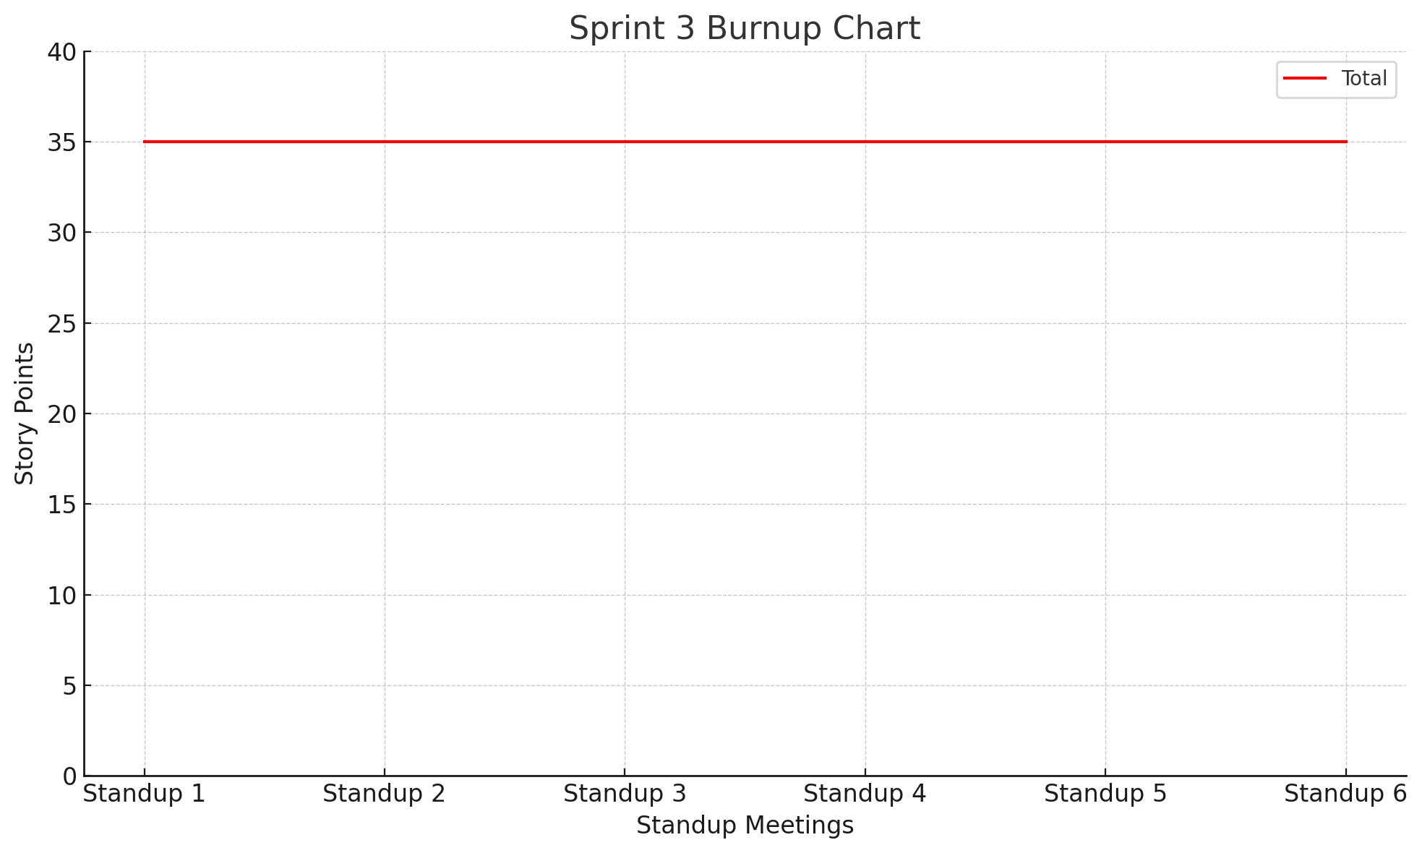

1. **Scrum Times**
   1. Week 5 (Sprint Begins Wednesday)
      1. Wednesday 11/6/24 - 11:00 A.M.
      2. Thursday 11/7/24 - 3:00 P.M.
      3. Friday 11/8/24 - 11:00 A.M.
   2. Week 6
      1. Monday 11/11/24 - 11:00 A.M. - **TA Meeting**
      2. Wednesday 11/13/24 - 11:00 A.M.
      3. Friday 11/15/24 - 11:30 A.M.
   3. Week 7 (Half Sprint)
      1. Monday 11/18/24 - 11:00 A.M. - **TA Meeting**
      2. Tuesday 11/19/24 - 1:30 P.M. - **End of Sprint 3**